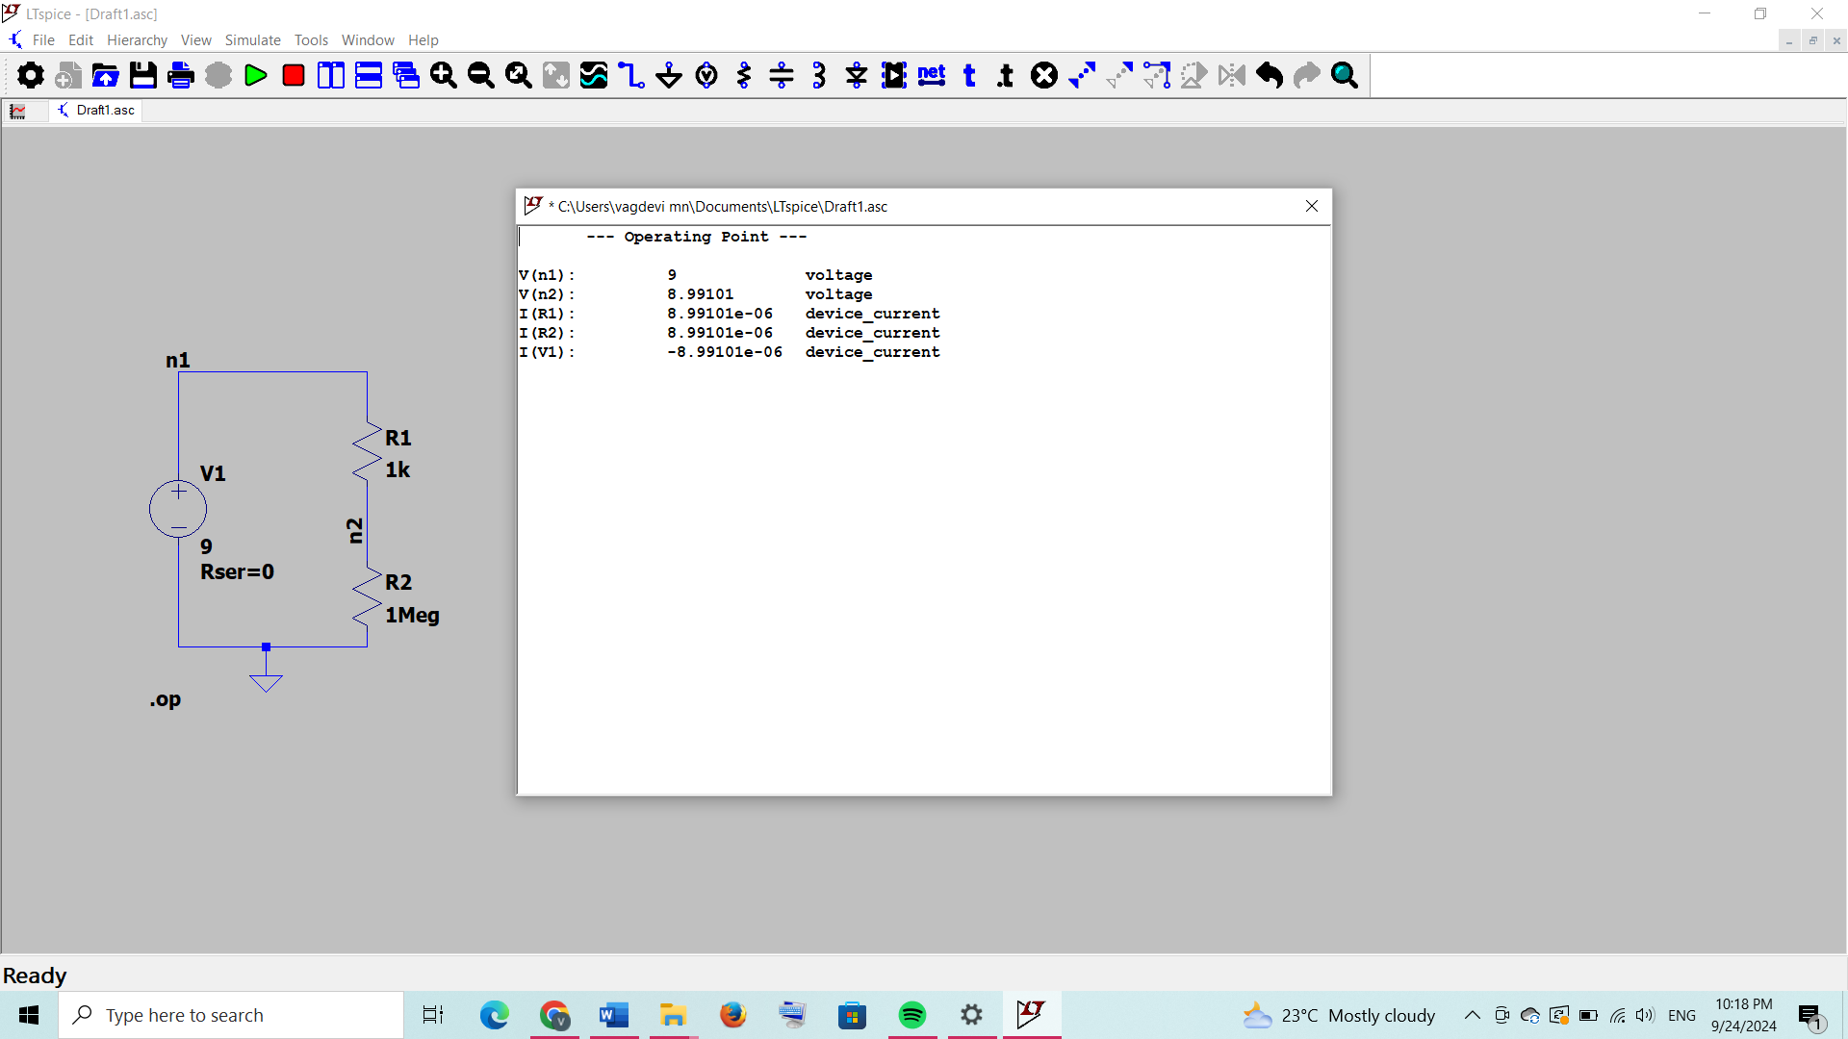

Voltage across n1 is as we have given it is 9 [v(n1)]

To find voltage across n2 :-

we have to find voltage drop in r1

I,e:-

I=v/(r1+r2)

I=9/(1000+1000000)=9/1001000)

I=8.99101e-06(it is current passing through r1 and r2) [i(r1) and i(r2)]

Therefore,

V=IR2

V=8.99101e-06\*e06

V=8.99101 [v(n2)]

And current accros v1 is same as current across

Resistors [i(v1)]